Write a program to implement wordcount using Pig.

//load the input file

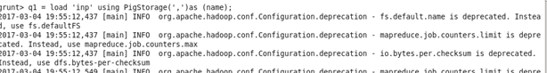

//dump the contents



//tokenize the contents of inp



//flatten operation



//group the data



//count the words and dump it

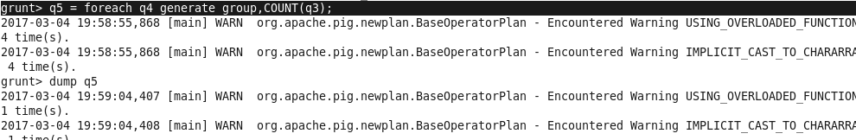

//result

